Cybersecurity Analyst Internship
Task Report

[samfelix15@gmail.com]
Task No: [10 - Phishing Identification]

Copyright © 2024 EncryptEdge Labs. All rights reserved
Credit: Offensive Security

Table of Contents
1.0 EncryptEdge Labs Internship Task Report
1.1 Introduction 3
1.2 Objective 4
1.3 Requirements 4
2.0 High-Level Summary 7
2.1 Recommendations 8
2.2 Risk exposure over time 8
3.0 Report - Methodologies 9
3.1 Information Gathering 10
4.0 Additionals Item 11
4.1 Screenshots 12
1.0 EncryptEdge Labs Internship Task Report
1.1 Introduction
Phishing is a type of social engineering attack that involves tricking individuals into revealing sensitive information, such as login credentials, financial information, or personal data. These attacks are designed to deceive victims into taking actions that compromise their security, often through emails, messages, or websites that appear legitimate.
Phishing identification is a crucial aspect of cybersecurity that involves detecting and preventing phishing attacks. Phishing is where attackers attempt to trick victims into revealing sensitive information, such as login credentials, financial information, or PII. These attacks can have devastating consequences, including financial loss, reputational damage, and compromised sensitive information.

1.2 Objective
Understand the concept of social engineering and its role in cybersecurity.
Explore and simulate common social engineering attacks.
Reflect on the ethical considerations surrounding social engineering tactics.
Define social engineering and explore its application in red teaming.
Understand and simulate common types of social engineering attacks.
Considering this report, the core objectives of phishing identification will include
1.3 Requirements
NB
To implement effective phishing identification, organizations, teams etc require:
1. Technical Controls: Implement technical controls, such as spam filters, antivirus software, and intrusion detection systems, to detect and prevent phishing attacks.
2. User Education: Educate users on phishing identification techniques and best practices to avoid falling victim to phishing attacks.
3. Incident Response: Develop an incident response plan to handle phishing attacks and minimize their impact.
Based on this report, I am obliged to,
Submit a summary outlining the importance of social engineering in cybersecurity, with a focus on the ethical considerations and responsible use of these techniques.
Gain hands-on experience with phishing simulations.
Submit a screenshot of the lab completion screen for verification.
TOOLS
Tools used for this report will include
Social Engineering Toolkit (SET)
Phishing Simulation Platforms: HiddenEye or similar tools.

Phishing Identification: A Critical Component of Cybersecurity
Phishing identification is a crucial aspect of cybersecurity that involves detecting and preventing phishing attacks. Phishing attacks are a type of social engineering attack where attackers attempt to trick victims into revealing sensitive information, such as login credentials, financial information, or personal data. These attacks can have devastating consequences, including financial loss, reputational damage, and compromised sensitive information.
How Phishing Attacks Work
Phishing attacks typically involve the following steps:
1. Target Identification: Attackers identify potential targets, often through publicly available information or previous breaches.
2. Attack Design: Attackers design a phishing attack, creating emails, messages, or websites that appear legitimate and convincing.
3. Attack Deployment: Attackers deploy the phishing attack, sending emails or messages to victims or hosting fake websites.
4. Victim Interaction: Victims interact with the phishing attack, often by clicking on links, providing sensitive information, or downloading malware.
5. Attack Success: If successful, attackers gain access to sensitive information, compromise systems, or steal financial assets.
Types of Phishing Attacks
There are several types of phishing attacks, including:
1. Email Phishing: Attackers send emails that appear to be from a legitimate source, such as a bank or online retailer, asking the victim to click on a link or provide sensitive information.
2. Spear Phishing: Attackers send targeted phishing emails to specific individuals or groups, often using personalized information to increase the likelihood of success.
3. Smishing: Attackers send phishing messages via SMS or text message, often using a sense of urgency to prompt the victim into taking action.
4. Vishing: Attackers use voice calls to trick victims into revealing sensitive information.
5.Whaling: A type of phishing attack that targets high level executives and important individual in an organization, often using personalized and sophisticated tactics to trick them into revealing sensitive information and performing certain actions.

Real-Life Scenarios
1. Email Phishing: An attacker sends an email that appears to be from a legitimate source, such as a bank or online retailer, asking the victim to click on a link or provide sensitive information.
2. Spear Phishing: An attacker sends a targeted phishing email to a specific individual or group, often using personalized information to increase the likelihood of success.
3. Smishing: An attacker sends a phishing message via SMS or text message, often using a sense of urgency to prompt the victim into taking action.

2.0 High-Level Summary
Phishing attacks can have significant consequences, including:
1. Financial Loss: Phishing attacks can result in financial loss, either through direct theft or indirect costs associated with incident response and remediation.
2. Reputational Damage: Phishing attacks can damage an organization's reputation and erode customer trust.
3. Compromised Sensitive Information: Phishing attacks can compromise sensitive information, including login credentials, financial information, or personal data.

By implementing these methodologies and best practices, organizations can improve their phishing identification capabilities and reduce the risk of phishing attacks. ‎

2.1 Recommendations
Based on my findings. I will highly recommend that, organizations should
1. Detect Phishing Attacks: Identify phishing emails, messages, or websites that attempt to trick victims into revealing sensitive information. Use advanced threat detection tools, such as machine learning-based systems, to detect and prevent sophisticated phishing attacks.
2. Prevent Phishing Attacks: Implement security measures to prevent phishing attacks from reaching users or succeeding in stealing sensitive information.
3. Educate Users: Educate users on phishing identification techniques and best practices to avoid falling victim to phishing attacks.
4. Implement Multi-Factor Authentication: Require multi-factor authentication to add an extra layer of security and prevent phishing attacks from succeeding.
5. Conduct Regular Security Awareness Training: Conduct regular security awareness training to educate users on phishing identification techniques and best practices.

2.2 Risk Exposure over Time
Phishing attacks can have significant consequences over time, including:
1. Financial Loss: Phishing attacks can result in financial loss, either through direct theft or indirect costs associated with incident response and remediation.
2. Reputational Damage: Phishing attacks can damage an organization's reputation and erode customer trust.
3. Compromised Sensitive Information: Phishing attacks can compromise sensitive information, including login credentials, financial information, or personal data.

3.0 Methodologies
Impact of Phishing Identification in Cybersecurity
1. Reduced Risk: Effective phishing identification reduces the risk of phishing attacks and protects sensitive information.
2. Improved Security: Phishing identification is a critical component of cybersecurity, improving overall security posture.
3. Increased Awareness: Educating users on phishing identification techniques increases awareness and promotes best practices.
4. Enhanced Incident Response: Phishing identification enables organizations to respond quickly and effectively to phishing attacks.

Techniques for Detecting and Preventing Phishing Attacks
There are several techniques for detecting and preventing phishing attacks, including:
1. Email Analysis: Analyzing email headers and content to identify suspicious emails.
2. URL Analysis: Analyzing URLs to identify suspicious links.
3. Content Analysis: Analyzing content to identify phishing attacks.
4. User Education: Educating users on phishing identification techniques and best practices.
5. Technical Controls: Implementing technical controls, such as spam filters and antivirus software, to detect and prevent phishing attacks.

Prevention and Mitigation
To prevent and mitigate phishing attacks, organizations should:
1. Educate Users: Educate users on phishing identification techniques and best practices.
2. Implement Technical Controls: Implement technical controls, such as spam filters and antivirus software, to detect and prevent phishing attacks.
3. Use Advanced Threat Detection: Use advanced threat detection tools, such as machine learning-based systems, to detect and prevent sophisticated phishing attacks.
4. Continuously Monitor and Evaluate: Continuously monitor and evaluate phishing attacks and security measures to ensure they are effective and up-to-date.
By understanding phishing attacks and implementing effective security measures, organizations can reduce the risk of phishing attacks and protect sensitive information. ‎

3.1 Information Gathering
To gather information on phishing attacks, organizations can:
1. Monitor Network Traffic: Monitor network traffic to detect suspicious activity and identify potential phishing attacks.
2. Analyze Email Headers: Analyze email headers to identify suspicious emails and detect phishing attacks.
3. Use Threat Intelligence: Use threat intelligence feeds to stay informed about emerging phishing threats and tactics.
By understanding the importance of phishing identification and implementing effective security measures, organizations can reduce the risk of phishing attacks and protect sensitive information
Based on this reports, information was gathered based on acquired knowledge, experience, provided Youtube videos and provided resourceful materials from EncryptEdgeLabs. They may include
Cheat Sheets or Notes:
Social Engineering Toolkit Cheat Sheet
GitHub Repos:
Awesome Phishing – GitHub Repo
HiddenEye – GitHub Repo
Social Engineer Toolkit (SET) – GitHub Repo
Articles:
What is Social Engineering?
Overview of Social Engineering
What is Phishing?
Social Engineer Toolkit
Social Engineering Toolkit and Zphisher
Unlock SET

4.0 Additional Items & Screenshots
This report is structured to provide,
1. Theoretical Background: We provide an in-depth exploration of social engineering, including its definition, history, and psychological underpinnings.
2.Tactics and Techniques: We discuss various social engineering tactics, including phishing, pretexting, and baiting, highlighting their characteristics and potential impact.
3. Prevention and Mitigation Strategies: We outline effective strategies for preventing and mitigating social engineering attacks, including employee education, technical controls, and incident response planning, Multifactor Authentications
4. Best Practices: We emphasize the importance of adopting best practices, such as verifying information, being cautious with links and attachments, and reporting suspicious activity.
To draw the curtains down, a step by step approach has helped me gained comprehension on the types of social engineering attacks and the necessary structured approach in performing these attacks However ,I was unable to simulate social engineering scenarios due to challenges I faced during the process and also, ethical considerations. My report provides a comprehensive overview of the topic, focusing on theoretical aspects, common tactics, and prevention strategies. By prioritizing caution (educational purposes) and responsible reporting, I aim to contribute to a more better understanding of social engineering and its implications for individuals and organizations.

Below will include screenshots of completion of my mandatory Lab exercises and other supportive screenshots, relative to my report. Thank you
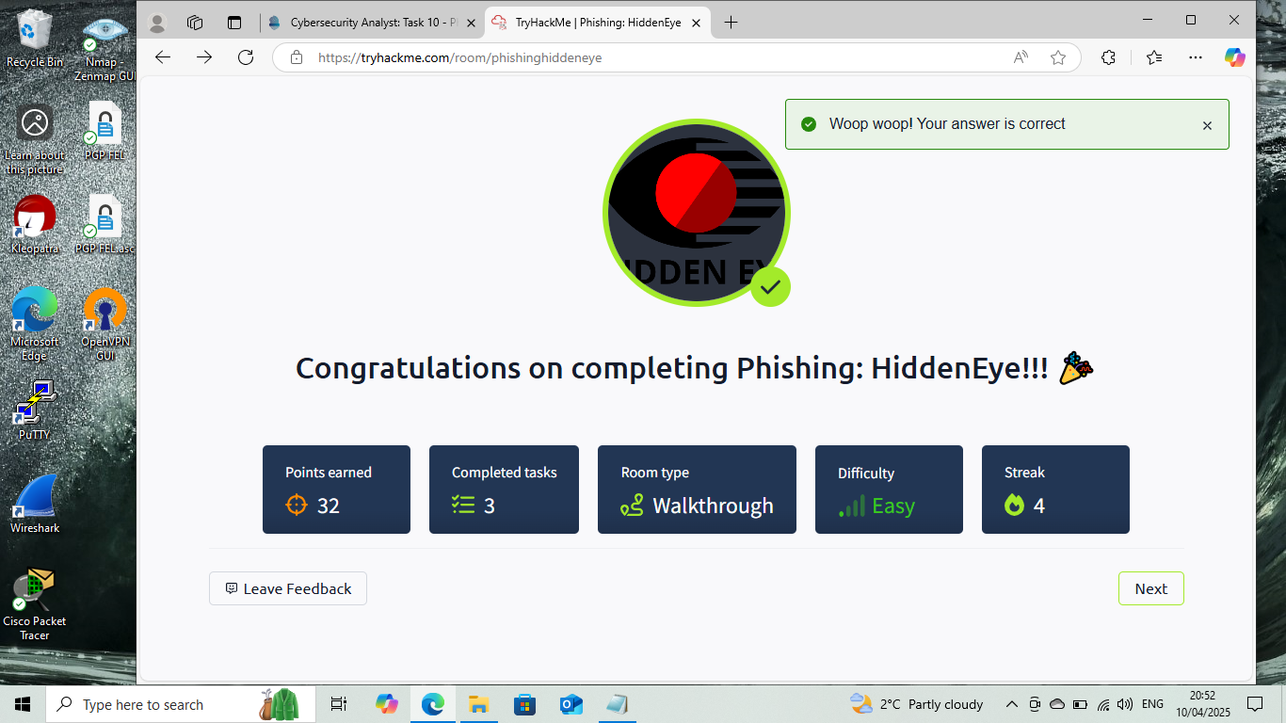

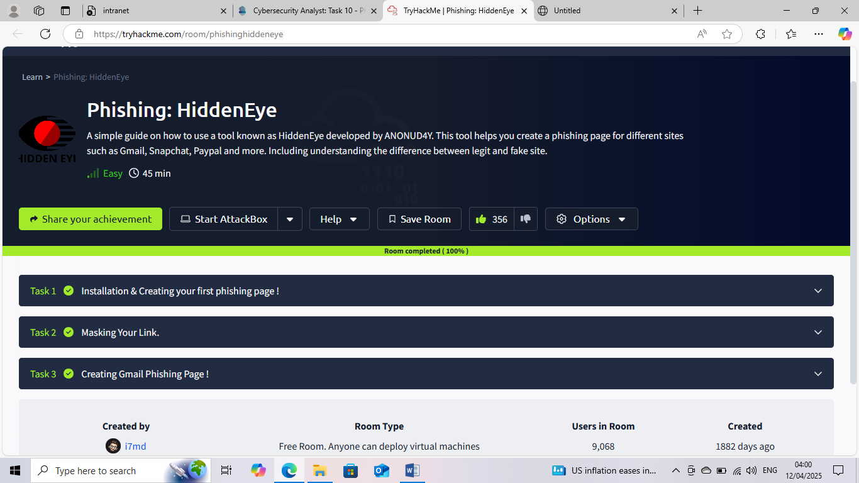


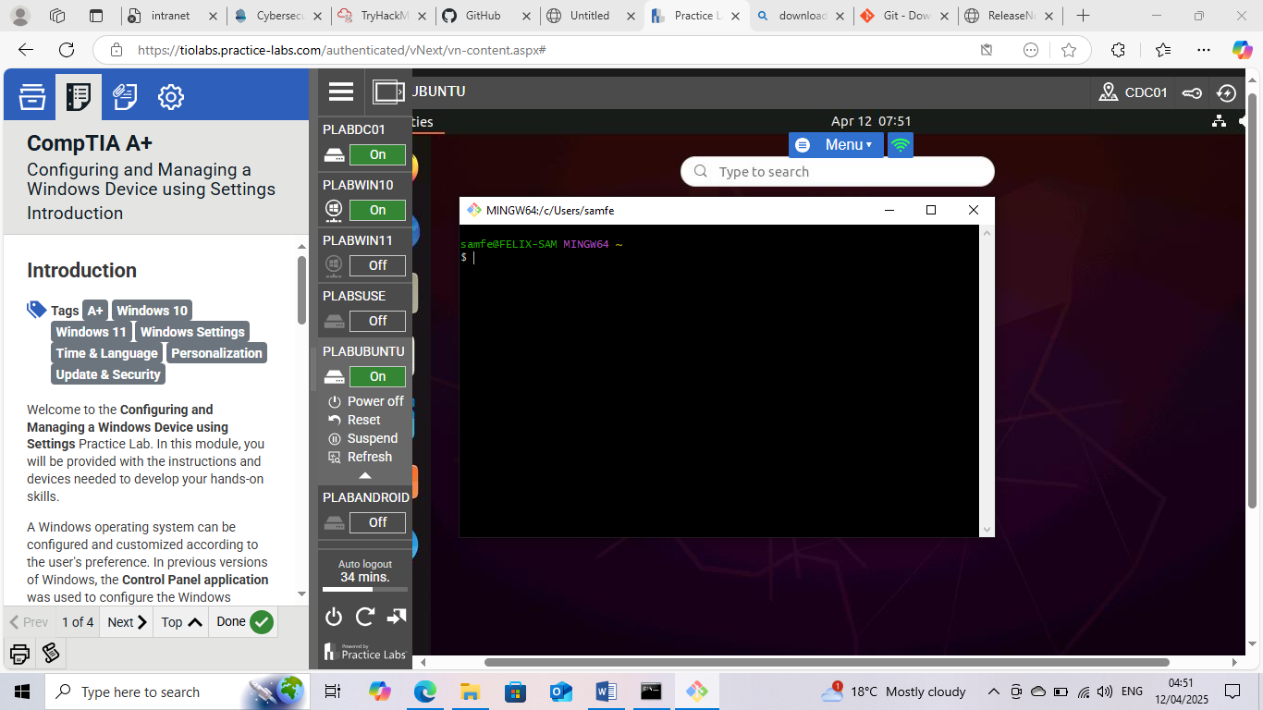
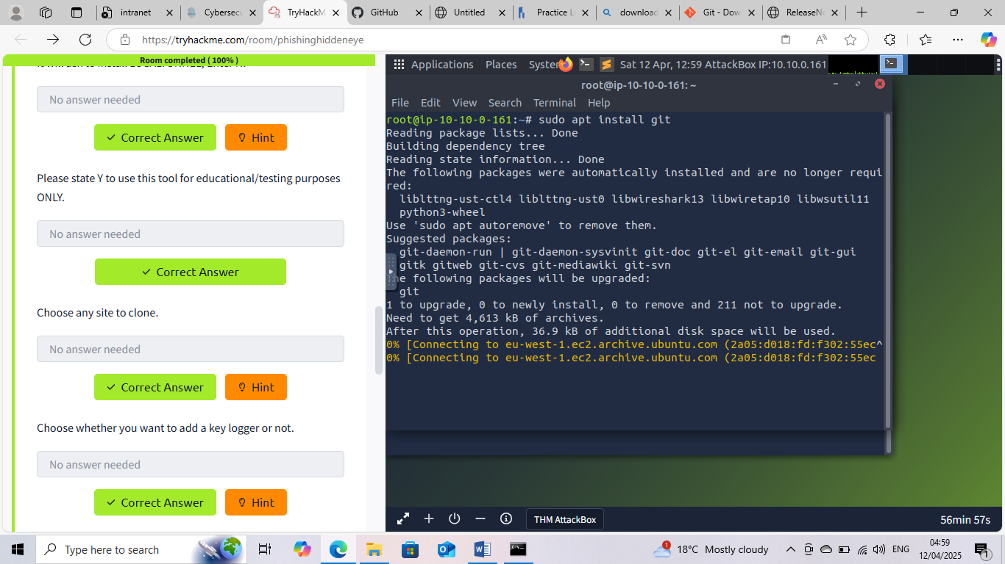
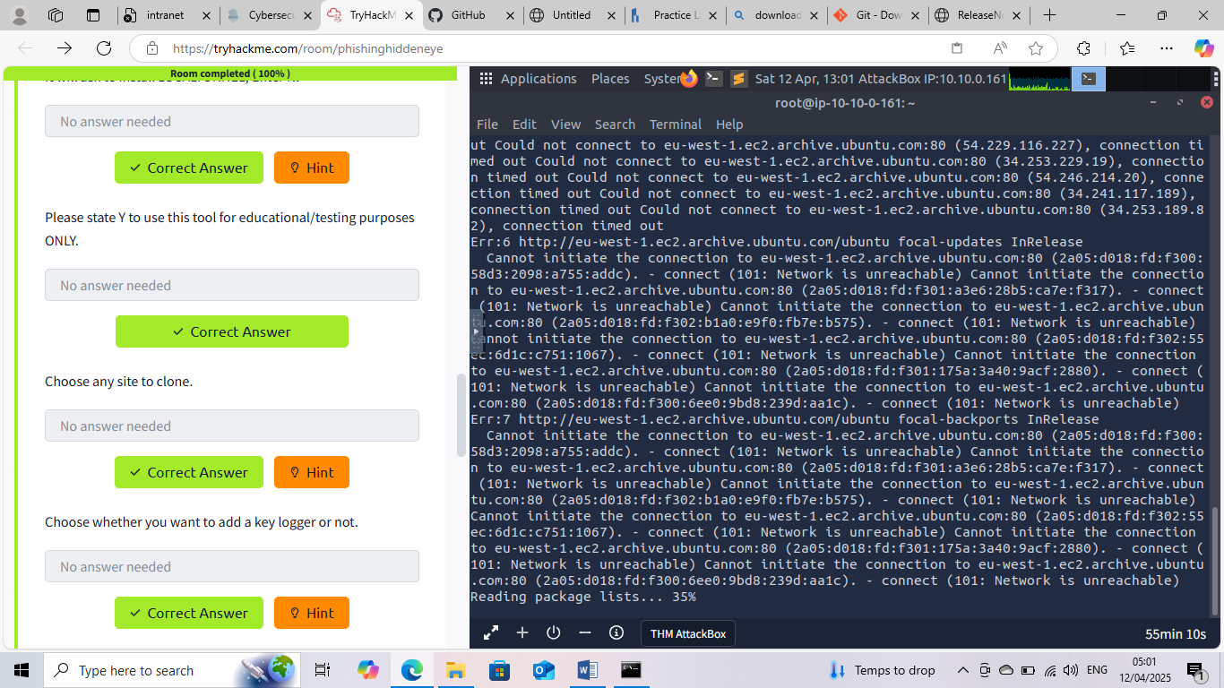
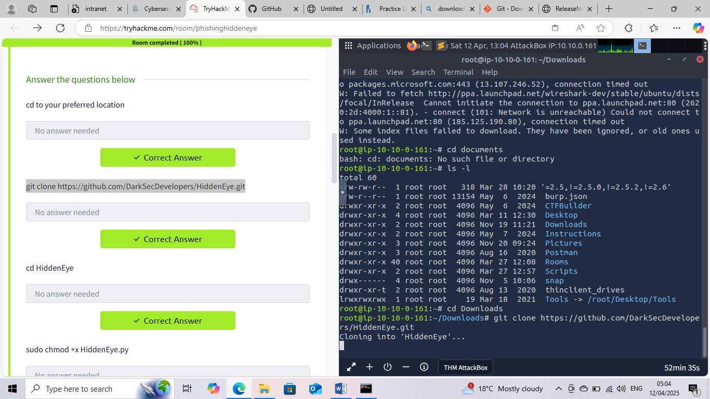

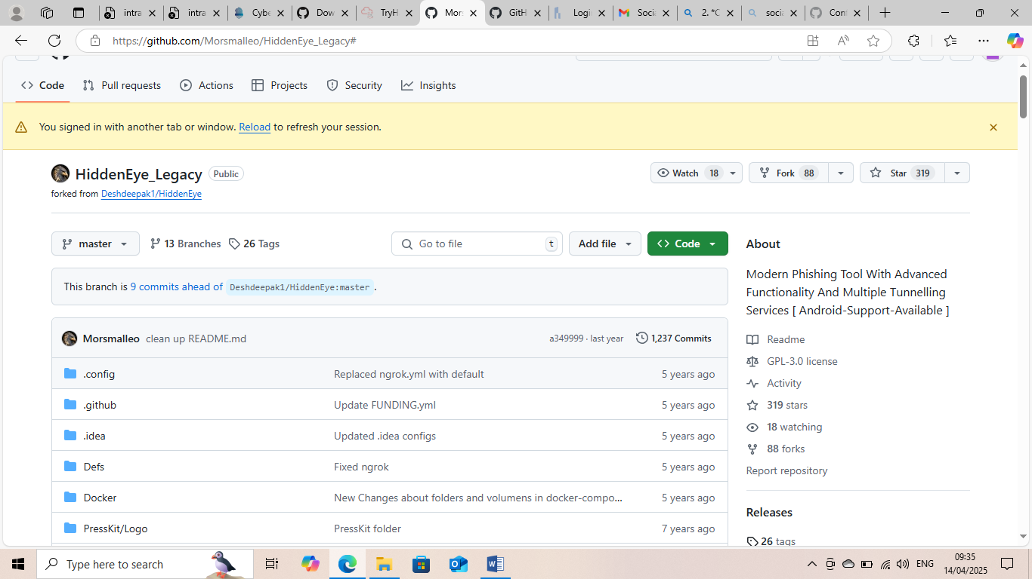

This Internship Task report was developed on [April, 14,2025]

By:
[samfelix15@gmail.com]

